**NAME: MUBARA ASFAQ**

**DEPARTMENT SE**

**ASSIGNMENT NO 4**

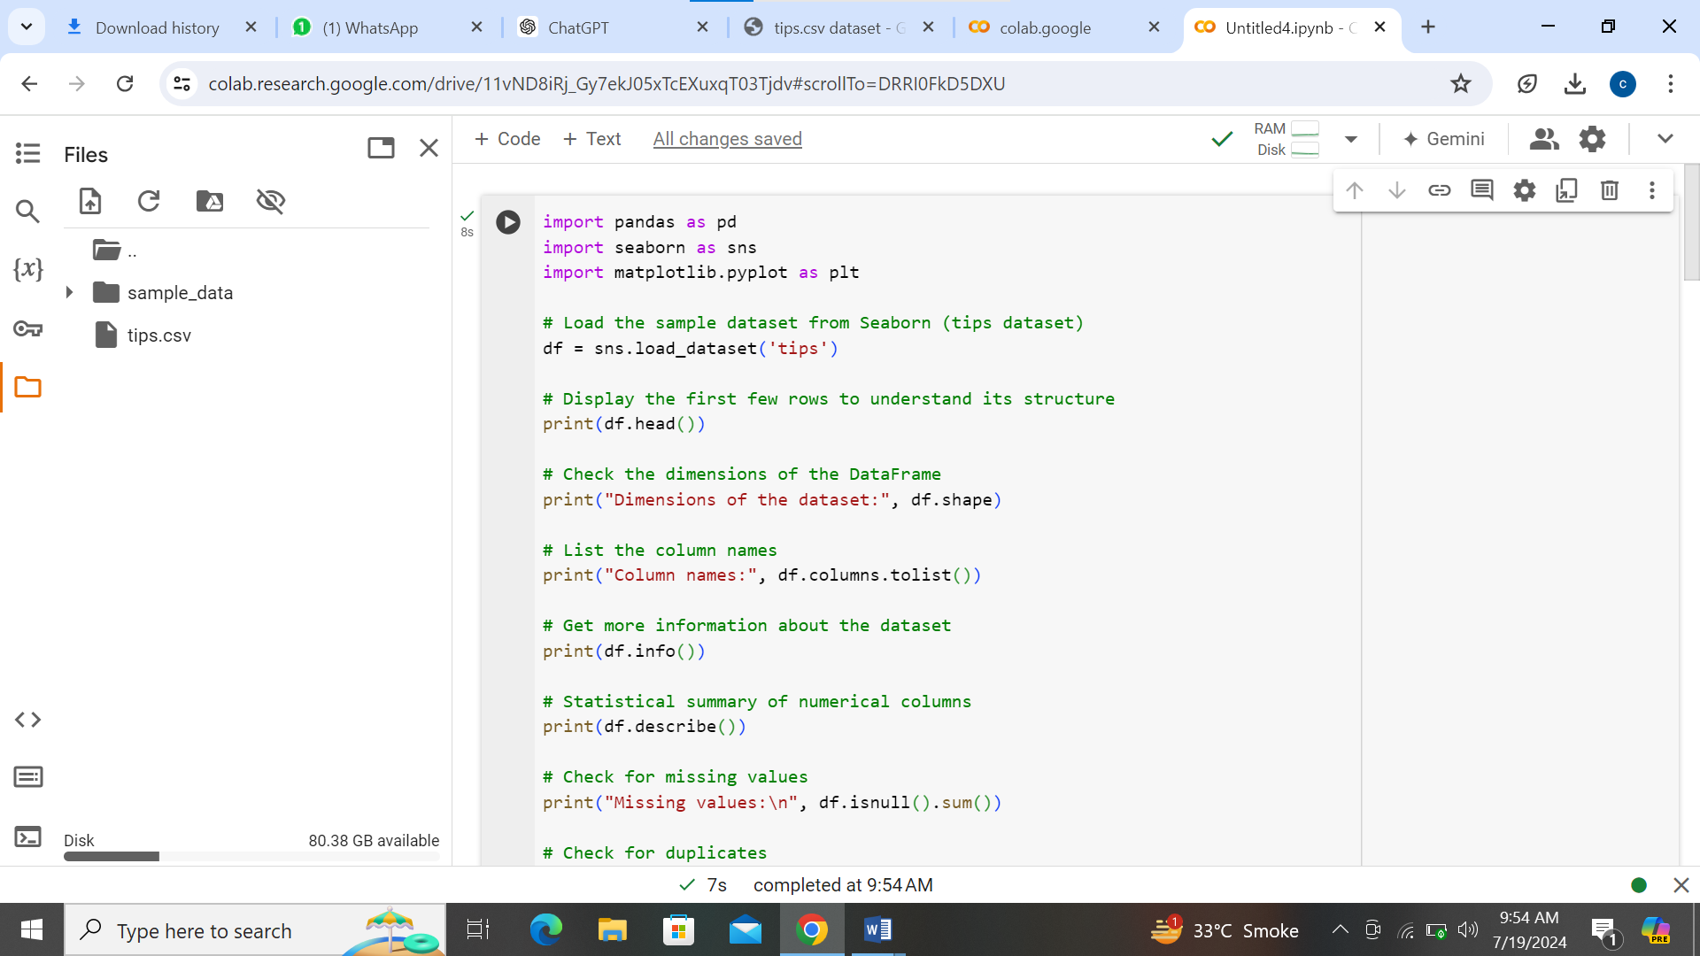

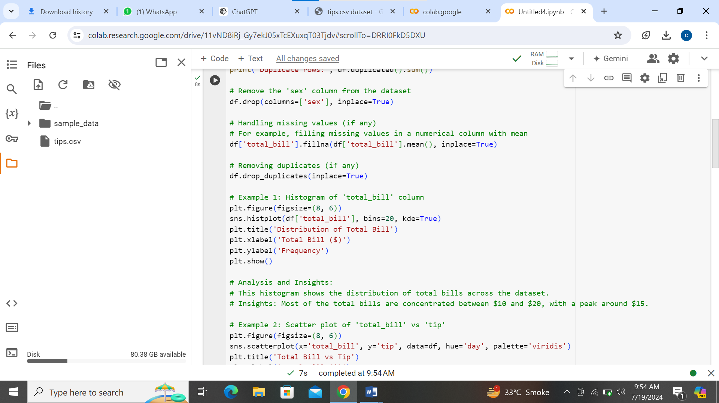

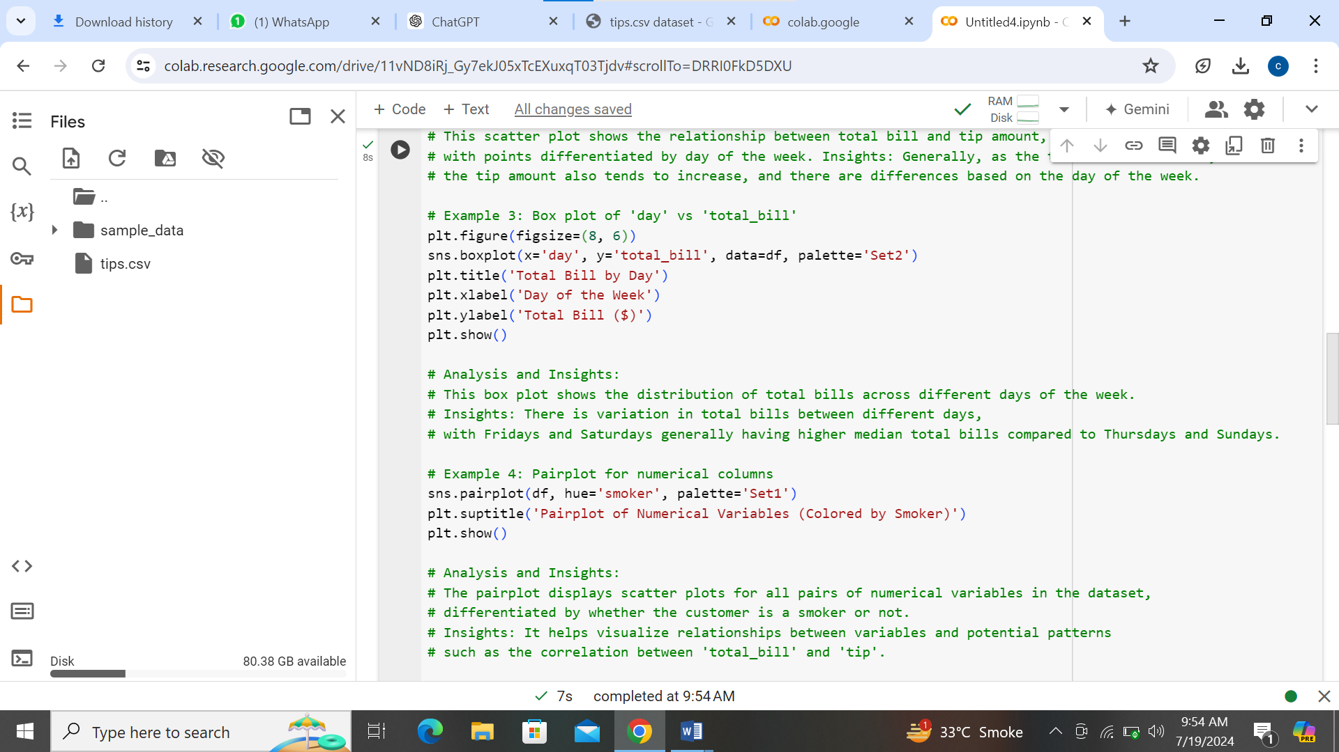

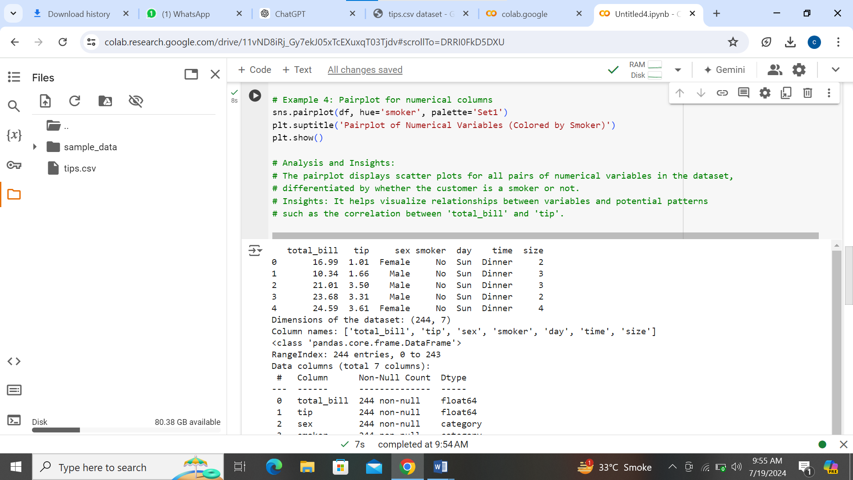

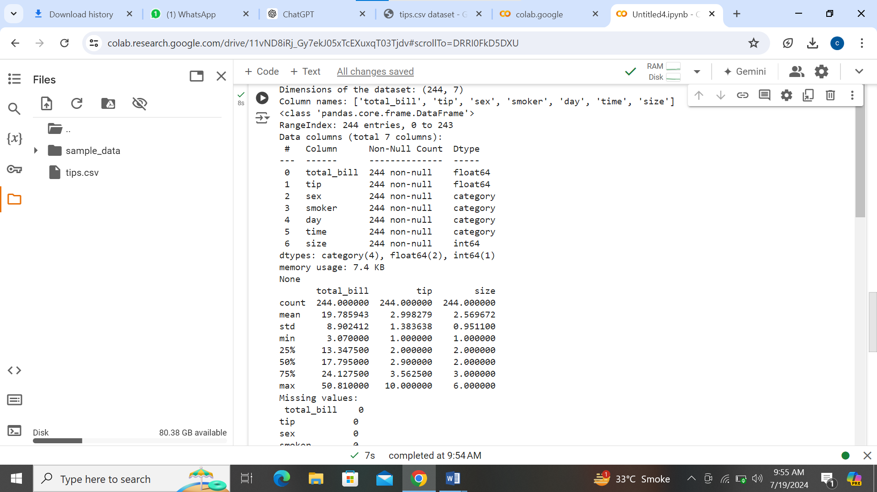

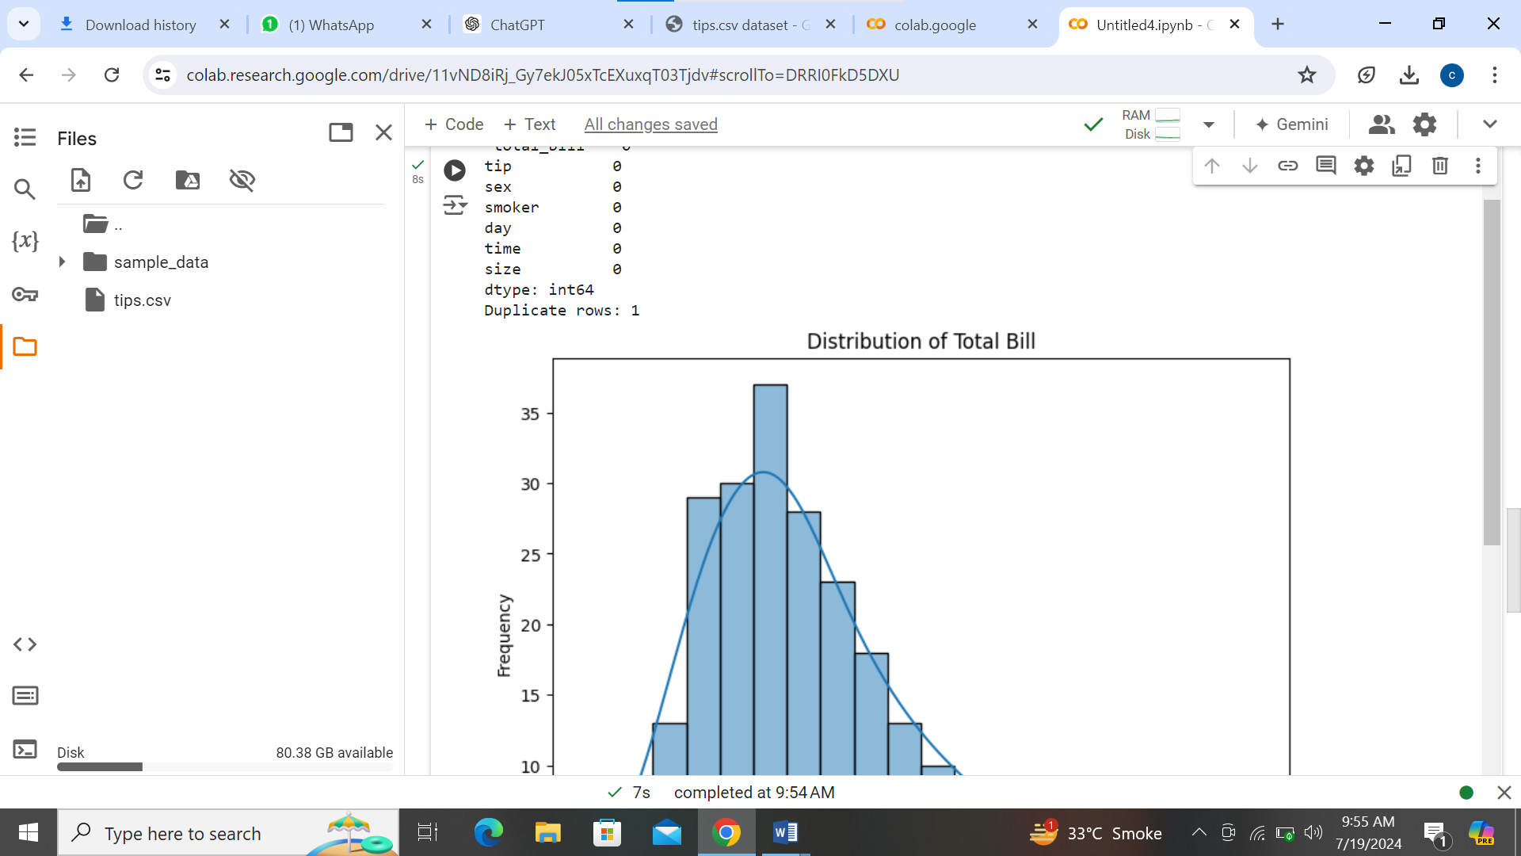

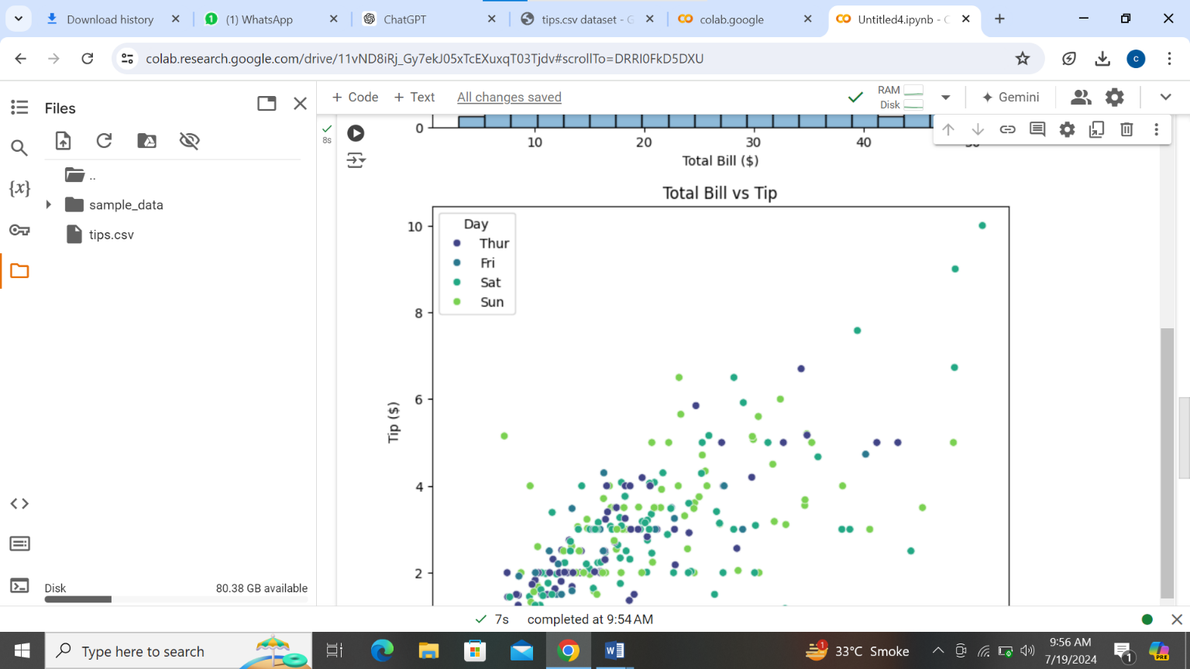

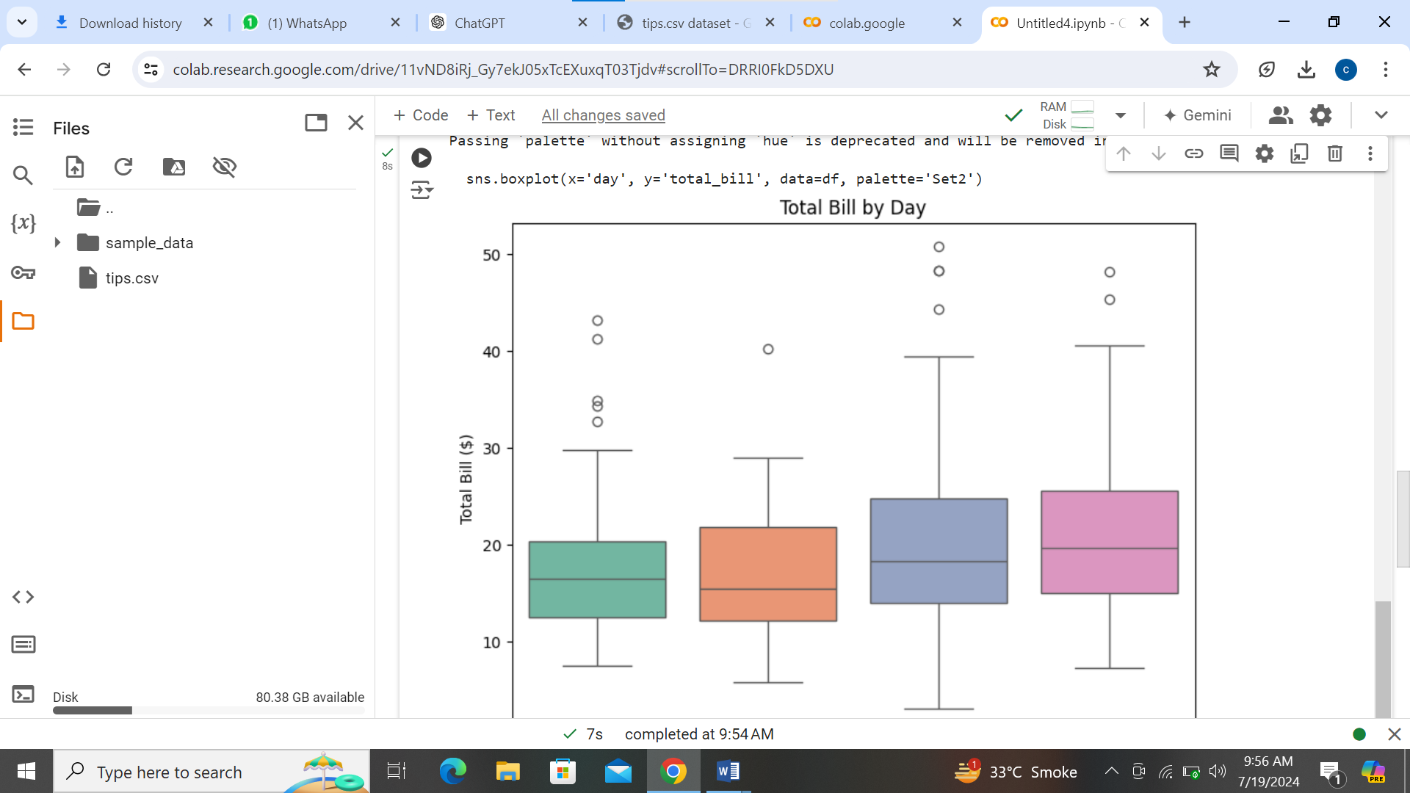

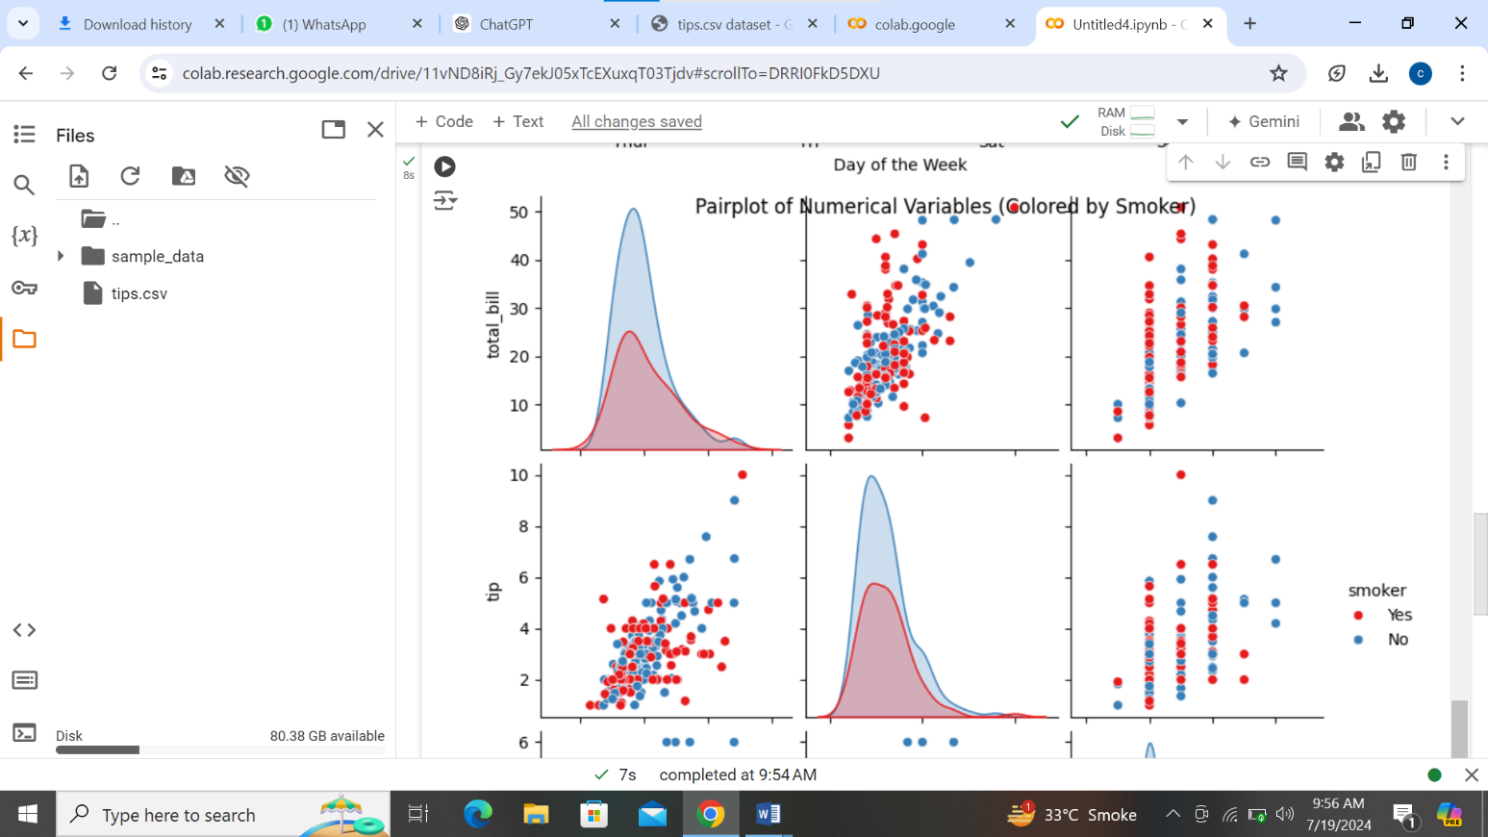

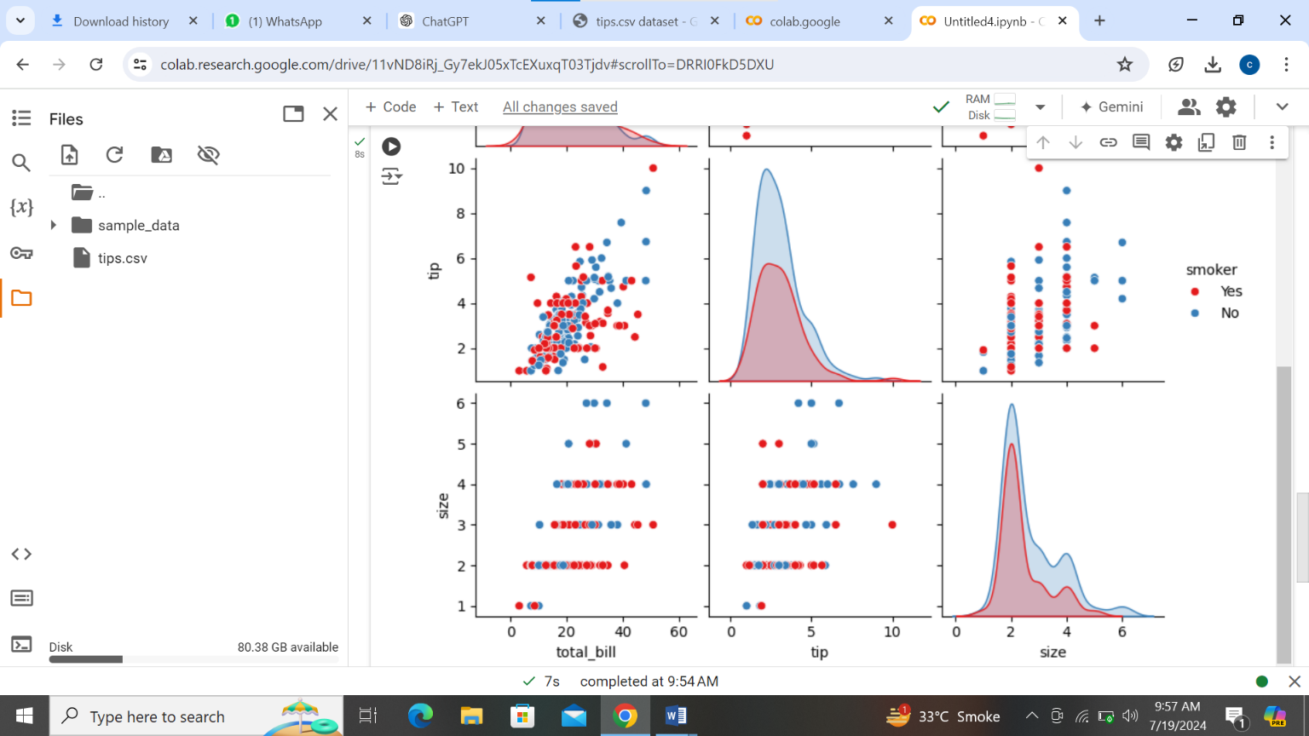

**Explanation:**

* **Dataset Loading**: The dataset is loaded using sns.load_dataset('tips') from Seaborn, which provides a sample dataset with columns including 'total_bill', 'tip', 'day', and others.
* **Data Cleaning**: Steps such as handling missing values (fillna()), removing duplicates (drop_duplicates()), and dropping unnecessary columns (drop(columns=['sex'])) are performed as part of data cleaning.
* **Visualization**: Various types of plots are created using Seaborn and Matplotlib:
  + **Histogram**: Shows the distribution of 'total_bill'.
  + **Scatter Plot**: Visualizes the relationship between 'total_bill' and 'tip', colored by 'day'.
  + **Box Plot**: Displays the distribution of 'total_bill' across different days of the week.
  + **Pair Plot**: Provides a matrix of scatter plots for numerical variables, colored by 'smoker' status.
* **Analysis and Insights**: After each visualization, insights are provided to explain what each plot reveals about the data, helping to understand patterns, trends, and relationships within the dataset.

This approach completes the assignment objectives by thoroughly analyzing and visualizing the dataset using Pandas, Seaborn, and Matplotlib, while also demonstrating effective data cleaning techniques. Adjust the code and visualizations further based on your specific dataset and analysis requirements.

Top of Form

Bottom of Form